Grand Canyon University

Project 5 – Self-Organized Criticality

Ryan Scott and Diego Guerra

CST-305: Principles of Modeling and Simulation Lecture & Lab

Dr. Ricardo Citro

November 13, 2022

**Introduction:**

As a result of the creation and deletion of files over time, the fragmentation of a file system increases. Once a file system reaches a critical point, it will be unable to operate anymore and will perform slower and take longer to access files. System performance will be affected and file access times will be prolonged. Using the Lorenz equation we learned about in class, we can simulate and graph what that critical point would look like. Simply put, as a variable in the simulation gets closer to the critical point, the graph becomes more unstable.

**Code for Lorenz Function:**

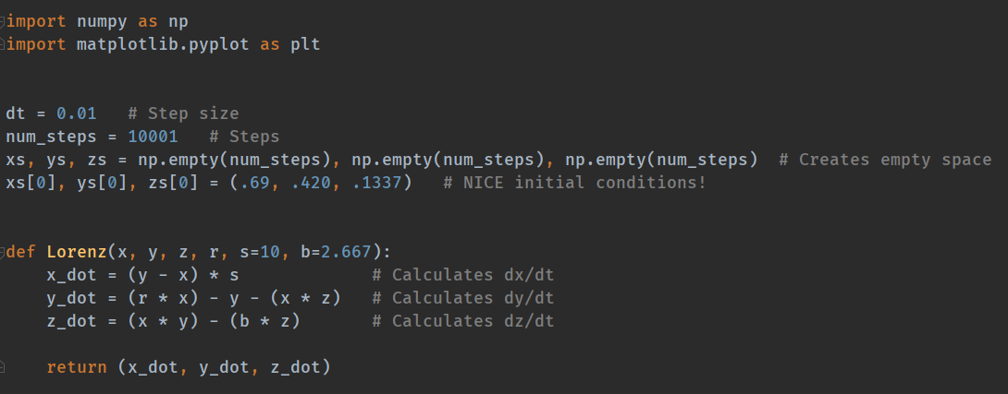

With:

* Three-dimensional point of interest **x**, **y**, **z**.
* Lorenz attractor parameters **s**, **r**, and **b**.
* Initial conditions of (.69MB, .42MB, 1.337MB)

We will find the derivatives of x, y, and z in relation to time by creating a function that takes in x, y, z, and r variables and passing constants into a Lorenz function in Python. The derivative values of x, y, and z will be added to an array and plotted in three dimensions with respect to t.

**Gather Points Generated by R-Value:**

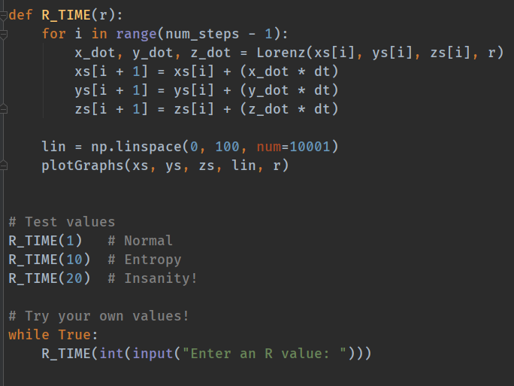

**Graph the Calculated Values:**

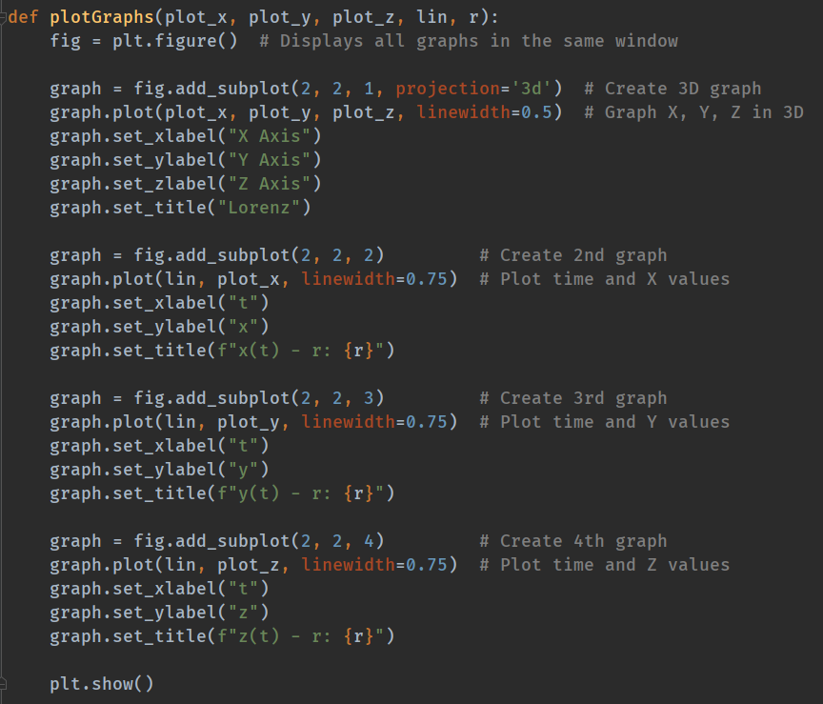

**Graphs:**

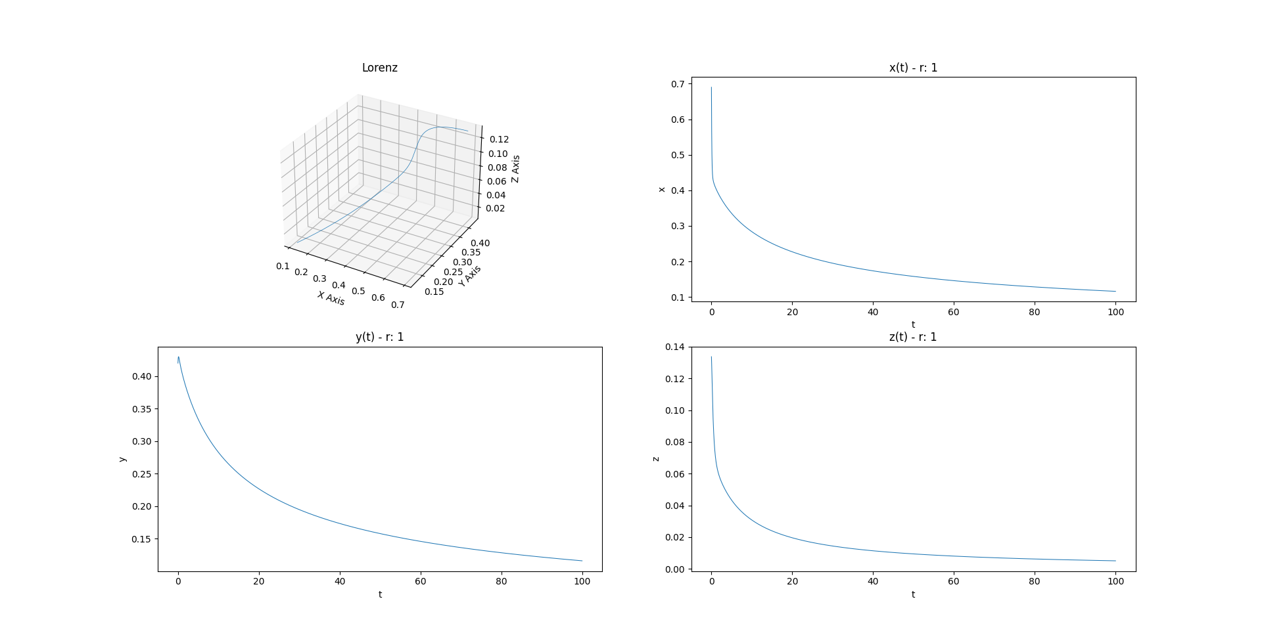

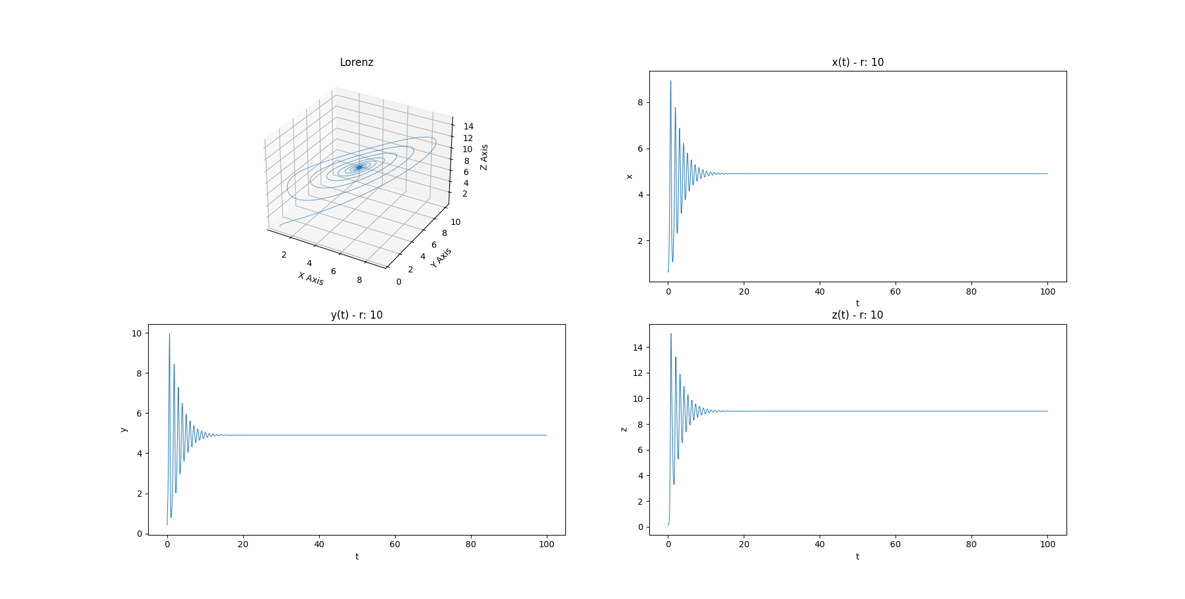

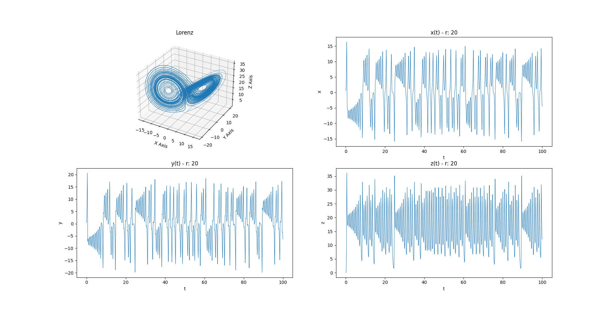

**Lorenz Graph Analysis:**

There are three R values used in this analysis: R = 1, R = 10, and R = 20. Increasing R causes the following 3D graph evolution:

* A curved line
* A line orbiting around one point
* A line orbiting around two points

As you can see on these hectic graphs with high R values, the system approaches this critical point which is analogous to a file system that is no longer functional. The graphs for each individual variable show how the file sizes will change as the R variable changes with time.